The Artifact Box Exchange Network

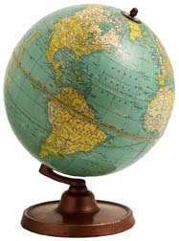
Materials for continuing participation in the
Artifact Box Exchange Network
Brian & Denise Reid
2408 4th Street
Charleston, IL 61920
Phone/Fax: 217-508-4515 artifactbox@gmail.com abox@schooltransformation.net
www.artifactbox.com

Welcome back to the Artifact Box Exchange Network!
I am glad that you enjoyed your previous experience with our project and have returned to provide this opportunity for your students by participating once again in the Artifact Box Exchange Network.
As you know, the Artifact Box Exchange is a national project to help students learn about their region and to connect with other students living across the country. Completed in both gifted and regular classrooms, this project gives students an opportunity to design and create a project that demonstrates a variety of knowledge and skills. Over 17,000 teachers have participated in 25 years of operation
Although the development of an Artifact Box is fun for students, the real value of the Artifact Box is engaging students in learning activities. These activities will help students learn social studies knowledge and skills and connect that learning to other content areas in meaningful ways using creativity and critical thinking. As you return and gain experience with the project, think about new ways you can work with your students, building increased skills especially developing innovative clues and building creativity skills with your students.
One of the questions that has been asked more and more over the past few years is using print resources versus Internet resources. This is a question that each teacher will have to answer for him/herself. The Internet provides extensive resources, but requires more critical thinking to extract the best information. I think the answer will come from those methods that each teacher finds the most effective to help students learn.
We have made a few revisions in the Teachers Guide and the clues. Most of the changes were requested by participants and I hope they will be as enjoyable as the past. As you work through this project think about ways you could share your experience with other teachers (and learn from them as well).
If you have new clues or strategies that might help other teachers, please send the ideas to me and I will post them on our website, and perhaps, include them in the next revision of the Teacher’s Guide.
Thanks,
Brian Reid Director
Deadlines and Disappointments
By its very nature, the Artifact Box Exchange Network requires a cooperative effort between five sets of people: The Project Director, the teacher in your partner classroom, the students in your partner classroom, your students, and you. If any one of these people fails to fulfill their obligations or honor a commitment to a timeline, then other people are inconvenienced and at times, disappointed.
For the majority of teachers and students who participate in this exchange project, the experience is a rewarding one. Letter after letter from past participants attest to the project's potential for creating an enthusiastic classroom environment and fostering an exciting learning exchange. However, we have also received letters from past participants who have been disappointed and less than satisfied with their students' Artifact Box experience. In all cases, the problem arose from one of three sources.
Problem 1: In some instances, a teacher gets behind and does not mail the box by the deadline. Delays will often occur, but you must communicate with your partner and keep them up to date on your progress.
Problem 2: A second difficulty arises when a teacher decides to withdraw from the project and send no box. The decision to abandon the project must be made in consultation with the Project Director before the Contract Deadline.
There have been several times when conditions in the classroom could legitimately force such a decision, the fact that the sending teacher did not communicate the difficulties to the receiving teacher or director compounded the problem. If the teacher had made plans for modifying the timeline or helped the partner teacher get a new partner with the aid of the project director, major disappointments for the youngsters enrolled in the receiving classroom could have been avoided.
Problem 3: The third problem that can arise has to do with the quality of the artifacts that are sent to the partner school. Although no one would expect a group of first grade students to produce a box that is as sophisticated and polished as tenth grade students, it is reasonable to assume that the students should submit work that is of high quality for their age and grade level. The role of the teacher in this experience is crucial. We must do more than simply introduce the concept to the students, collect their work, and transport the box to the post office. Teachers must fulfill their responsibilities as project coordinator and facilitator. The students should be encouraged to collect and send unique and appealing artifacts rather than simply submitting the first object that comes to mind. Reference clues should be written in rough draft form and later rewritten and polished before being submitted into the box.
Attention to these factors: deadlines, communication with your partner teacher, and the quality of your students' box, will assure a rewarding experience. Please don't disappoint the youngsters. Quality control is in your hands.
Action Timeline
This is the schedule of actions that must be taken for a successful participation in the Artifact Box Exchange.
Fall: September 30 (or Spring: January 30) All registrations must be received or postmarked by this date to be accepted. All registration forms must be accompanied by a check or purchase order and received by mail -sorry, no telephone orders can be accepted. Please do not complete a registration for a teacher other than yourself. You will be mailed your teaching materials approximately two weeks after we have received your registration and payment or purchase order. If you do not receive your materials within three weeks, please call. You may register for a future exchange at any time. You should begin your box as soon as you receive your materials. Please allow 6-8 weeks to complete your box.
Fall: October 22 (or Spring: February 22) Confirmation contracts must be returned to the office by this deadline. These confirmation letters will be included with the teaching materials or mailed separately. No one may confirm a registration for a teacher other than that teacher. Participants who wish to withdraw must notify the project directors by this date. Registrations may be transferred to a future exchange or refunds given (minus $5.00 processing fees) only if notification is made before this date. No teacher will be matched if this confirmation is not received by the deadline.
Fall: November 15 (or Spring: March 15)
By this date all confirmed participants will be mailed the name and address of his/her partner’s classroom. Please allow 3-5 days for this mail to reach you. If you do not receive this information by the 22 of the month, please call. Teachers must contact their partners as soon as they receive this information.
Fall: November 25 (or Spring: March 25)
On this date all participants must mail their completed Artifact Box to their partner classroom. Do not mail your box until you have talked directly with your partner. If you cannot contact your partner, please call us immediately. Do not change this date unless you have made explicit arrangements with your partner. The students should use research and reference skills to uncover the mystery location.
Fall: January 29 (or Spring: May 10)
This is the last day for teachers to return their Artifact Box and evaluation cards to their partner teacher. Please handle the box with care. Please remember that this box and all materials inside are only borrowed from your partner and must be returned in a timely manner. Many teachers reuse this box for future exchanges.
Artifact Box Exchange Clues
CLUE #1: Weather Forecast
Describe the weather in your region and town.
Locate local newspapers and clip daily weather report maps and forecasts for each of the following months: February, May, August, and November. Make a copy of each of the four maps and forecasts, and include them as one clue. Be sure to blacken out, white-out or cut out any mention of your town or state name. You may want to mount each map on tag board and laminate the maps for durability. Another option is to copy the artifact on a copy machine after you have removed or covered up obvious information.
- Where might you find old copies of last year's newspapers?
- What other ways could you illustrate the weather patterns of your town?
- What clue might you give to the finder to help him or her read the weather maps and forecasts and determine your region of the country?
- What are the best references for finding this information?
- Include information like average rainfall, temperature, yours of daylight at different times of the year,
- What are innovative or creative ways to display your information?

CLUE # 2: Geography and Land Forms
Describe topology of the land in your town and region.
Topographical Map: Find or create a map of the landforms in your area.
- What are the important landforms in your state, region, or town?
- How could you illustrate those landforms?
- How could you describe how the land is used (now and past)

CLUE # 3: Non-Edible Vegetation
Describe the vegetation in your town and region.
Locate a sample of local vegetation that is non-edible (the peas from your cafeteria won't be considered non-edible vegetation for this project!). How will you decide which vegetation will be a good clue for your location? How large should it be? Will it rot? Be sure that it will fit in a Zip-Lock bag and that you can find a good reference book to suggest to help in identifying the sample. Please be sure that it is a typical piece of vegetation and not a highly unusual one.
- What is the state flower tree or other vegetation??
- What are the local trees?
- What are the local plants?
- What else grows in your area?

CLUE # 4: Tree Leaves, Branch, and Bark
Describe the kinds of trees in your town and region.
Locate a small branch containing a few leaves and a small piece of bark from a tree that is very typical to your area. Follow the guidelines with Clue #3. Why must you include a branch with leaves on it rather than just a single leaf? Don't forget to recommend a good tree identification field guide for the Clue Sheet. If the leaf is brittle you may want to seal it in contact paper or iron on wax paper before you send it.
- What is the most prevalent tree in your town? How would you find out?
- What is the state tree?
- What uses do people in your region use trees for?

CLUE # 5: Food Product
Describe the foods that are produced in your area.
Find a sample of a food product that is produced in this area. It can be a local cash crop or a manufactured food product like candy or prepared foods. Be careful to remove any writing that would give away the town or state location on the package. Is it wise to include a food sample that might rot or decay? What unique foods come from your area?
• What food is produced in your town?
CLUE # 6: Manufactured Product
Describe a product that is manufactured in your town and region. Research products that are manufactured close to your town. Which products or industries are the most common? How will you include the product in your Artifact Box? Will you use a picture or model? A sample of the products? A box that used to contain the product? What clues will you write on the Clue Card?
- Are there any products or industries that are particularly identified with your region of the country or state?
- What is the most important product produced in your town?

CLUE # 7: Population
Describe the population in your town and region.
How can you find out the number of people that are living in your town? Who could give you that information if you were to make a local telephone call? How recent would you like the information to be? Write this number on an index card; label it as the population figure for your town. You might wish to include different population figures for the history of your town to show how and when the population has changed. How can you suggest a reference for this clue without giving away your state or province, or, will the researcher need to know your area first?
- What is the distribution of the population by ethnicity, religious denomination, heritage, age, gender, or other category?
- What has changed over the past 500 years? 200 years? 100 years? 50 years? 25 years, etc.

CLUE # 8: Typical Clothing
Describe the clothing work in your town and region throughout the year. How can you include examples of typical clothing for your area? Just exactly what is typical? Will you choose summer, winter, fall or spring styles? Or all of them? Why? How will you insure that the clothing is truly typical for your region? Is there any kind of clothing or piece of apparel that is unique to your area? What information will you provide for the Clue Card?
- What kinds of clothes do most people wear most of the year?
- What is the most common clothing in summer, fall, winter, spring?

CLUE # 9: Soil Sample
Describe the kind of soil that you have in your town and region.
We need some soil that is common to your region. Where is the best place to go for this sample? It may be a good idea to include photographs of your local topography as well. What reference book or resource person could help you make this a meaningful clue? What information could you include on the Clue Card? This can be a fascinating, but difficult, artifact to collect and reference.
- What is soil made of? What is different between your soil and soil in other places?
- What expert can you find to help you answer these questions?

CLUE # 10: Class Picture
Describe the students in your classrooms.
Take a photograph of all of the people who helped make this Artifact Box. Include a caption to identify the names of the people. Might the names also be a clue to your location? Can you find an instant camera to use for this photograph? What might you include in the picture to serve as clues to the location of your town? This will be a good time to learn about photography skills. Don't forget to include helpful information on the Clue Card.
• What clues can you hide in your picture to suggest the location of your town?
CLUE # 11: Telephone Book Sample
Describe the town by using clues from a local telephone book.
Find an old copy of your town's telephone book. Is there a section in the yellow and/or white pages that you might cut out, mount and laminate for inclusion in the box?
- How can telephone numbers help identify a region or town?
- Will you let them see the numbers of your area code? Why or why not?
- If you decide to use a yellow pages' ad, how will you decide which ad to use? What clues will you suggest that won't be too obvious or difficult? Are there advertisements for products or services that are unique to your town or region?

CLUE # 12: Portion Of State Or Province Map
Describe the location of your town based on an incomplete map of the town or region.
Find a state or province map and cut out a two-inch square portion of it to include for this clue. How will you determine what you will include on the piece you cut out? Will you include highways, rivers, or cities? You may need to blacken out some names. Perhaps you can include only parts of some names. What books can you suggest for references?
- Where will you find a map?
- How will you decide which part of the map to use?
- Will you show any highways, rivers, landmarks or railroads?
- Is there anything printed on the map that makes it too obvious? Should it be blackened or cut out?
- Don't forget to mount the map on cardboard or heavy paper and laminate it or cover it with clear contact paper. What other ways can you display the information?

CLUE # 13: Local Advertisements
Describe your town or region based on advertisements in the local media.
Read the advertisements in the local newspaper for three or four days. Do you find some ads for jobs or goods that you would consider typical for your town? Which will you choose to put into your box? Mount them on poster board and laminate them. How can these be used as clues? Will you allow street names and telephone numbers to remain on the ads or will you blacken them out? It might be fairly difficult to turn this artifact into a usable clue for the reader. Be very careful about your decision to include certain ads.
CLUE # 14: Rock Or Mineral
Describe the geology of your town and region.
Find a few typical rocks or minerals found in this area and package them in Zip-Lock bags. How can you be sure that these are typical for your region? Who might you consult to help you make this decision? What reference book will you suggest the reader use to identify these samples?
- What is the state rock?
- What is the state mineral?

CLUE # 15: Typical Home
Describe the typical home in your town and region.
Find or take photographs of typical homes found in your town. What will you include as being "typical"? You might wish to include homes that are the oldest in your town. How will the homes you include be of use in discovering your location? Is there something about homes in your area that is not typical of other homes in the country or world? Is there a home that has special historical or architectural value? If so, be sure to include this feature in your photograph (or model) and mention it on the Clue Card. Where can the researcher go to find out the information about these houses?
CLUE # 16: Regional/Local Foods and Recipes
Describe the regional foods that are representative your town and region.
Find a local recipe book. Make sure it includes regional foods. Find a recipe or two that is well known and copy or write them out. You must be careful to include a local recipe. If not, the clue will not be of any use to the reader. For instance, mashed potatoes are made in many parts of the world, but boiled lobsters are famous only in certain parts of the world. Where or to whom might you suggest the researcher go to find the clue's answer?
• What is the most popular kind of restaurant in your town? How would you find out?
CLUE # 17: State Birds and Animal
Describe the official birds, animals, insects, or other legally or adopted creatures
Try making this clue more interesting by including an index card that lists the scientific name for your creatures. You may need to consult a field guide or ornithologist to be sure that you have the proper name.
- Would you also like to include a picture or model of the creature? Why or why not?
- What will you write on the Clue Card to help the researcher find the answer?
- What book can he or she use to find the scientific name?

CLUE # 18: Animal
Describe the kinds of animals indigenous to your town or region.
Can you find a picture or make a model of an animal that is common and typical of your region? You may need to include more than one in order to make this clue useful. Don't include a picture of your pet cat or hamster. What we really need is a wild, undomesticated animal. How will you decide what animals are common to your region? It might be fun to arrange a visit to see some of these animals, or to have them visit us! Can you suggest a reference book that tells where the animals are commonly located?
CLUE # 19: Historic Landmark
Describe the kinds of historic landmarks in your town and region.
Are there any historic landmarks or famous buildings in your town or area? What are they? Are they well-know? Remember that you should recommend a book or resource that the researchers can also find if they are to locate the location of the clue. Include photographs and descriptions on the Clue Card for each historic location.
CLUE # 20: Famous Person
Describe the people who were born in your town. Lived a substantial amount of time, or did something notable in your town and region.
Ask several people around town for the name of famous people, living or dead, who live or used to live here. It isn't necessary that the people have spent all of their lives here. Now, can you find a photograph of these people or person? Will you include their names or just the pictures? How will you suggest the finder attempt to identify the persons and find out where they lived?
- National, State or Local leader
- Artist or Musician
- Athlete
- Scientist
- Actor or Actress

CLUE # 21: Newspaper Headline
Describe the stories that are common in your local newspaper.
Take a careful look at the headlines of your local newspapers for the next few days. Are there any headlines that a person living far away could use to discover your location? You may also want to look at newspaper headlines from the past year or so. How will you find these old newspapers? Be sure to include headlines that refer to local or state issues that are recognizable as being from your area. You will need to include a few headlines to make this clue meaningful. How will you suggest the researcher solving this clue find out the needed information? This can be a very tricky clue to assemble.
- Does your town have a local newspaper?
- Does your school district have a newspaper? School?

CLUE # 22: Letter Envelope
Describe the location of the town with partial postal code.
For this clue you will need to find a letter that was mailed from your local post office and has a local postmark on the envelope. Clip the cancelled postage stamp and cancellation circle from the envelope. Blacken the last two or three numbers on the zip code or postal code and attach this piece of paper to poster board before you laminate it. How is this a helpful clue? Where can the researcher go to research your location?
CLUE # 23: Recreational Activities
Describe the common recreational activities of your town.
What are the most popular sports, cultural or recreational activities that are offered in your region? Can you find ticket stubs, brochures or objects that advertise this event or place? Be sure to blacken out any give-away names. Include the items you collect along with suggestions for finding their location on the Clue Card.
CLUE 24: Local Author or Illustrator
Describe the local authors or styles of writing that have been common to your region or town.
Who are some regional or local authors that have published from your area (Thanks to Tricia Beck Sycamore Elementary School; Corona de Tucson, AZ)
CLUE # 25: Original Inhabitants and Immigration Patterns
Describe the immigration patterns of your area over time.
- Who were the original human inhabitants of your region? How did they live? What happened to them?
- What cultural groups have come to your area over the years? What are the local customs that have changed over the years (food, housing, transportation, etc,)
- Should your clue provide the name of the native inhabitants, or will examples of the

ancestral clothing or housing be sufficient? (Thanks to Victoria Lynne Williams, a student in the R.I.S.E. Program in Bellevue, Ohio, for suggesting this clue!)
CLUE # 26: Other Helpful Clues
Please select one or more of these clues to describe your region or town
Can you think of other artifacts that would be helpful to the students to whom you send your box? Is there a special artifact that you would like to include that we haven't included? You can make this clue easy or tricky to solve. It can even be an original picture, story or poem. It could be a puzzle that you create. It may involve science, history, geography, art, music, or whatever! Be creative! Write a letter to the Artifact Box Exchange Network Director about your new clue. He may include it in future Artifact Box direction sheets!
- National Park located near town or annual pageant or festival. Contributed by Gail Barduson, Dolson Hill School.
- Picture of state quarter or logo from a company in the state or town. Contributed by Kathy Hardesty, Smith School
- State Flower, State Wild Animal, State Tree, or School Mascot. Contributed by Mary Melville, Ludlow Elementary School.
- The oldest _____ found in your state or town; the first _____ found in your state or town; the most _____ found in your state or town, etc. Contributed by Norma Metz, Carpenter Elementary School.
- Include legends, myths, or folklore from your area. Contributed by Deb Rose, Riverstone Community School, Boise, Idaho.
- Include an edible clue that can be easily shipped. Contributed by Alyson Boyer, McMurray Elementary.
- Include picture puzzles, brainteasers, riddles, hands-on activities, class videos, etc. to showcase clues. Contributed by Jan Hoeffler, Parkview Intermediate School.
- Include a picture of the state capitol building or well-known colleges, etc. (Contributed by Mark Appleby, Moore Elementary School, Bath, Pennsylvania)
- Historical Event, Famous Homes, or Festivals Contributed by Paula White, Crozet Elementary School, Albemarle County Schools.

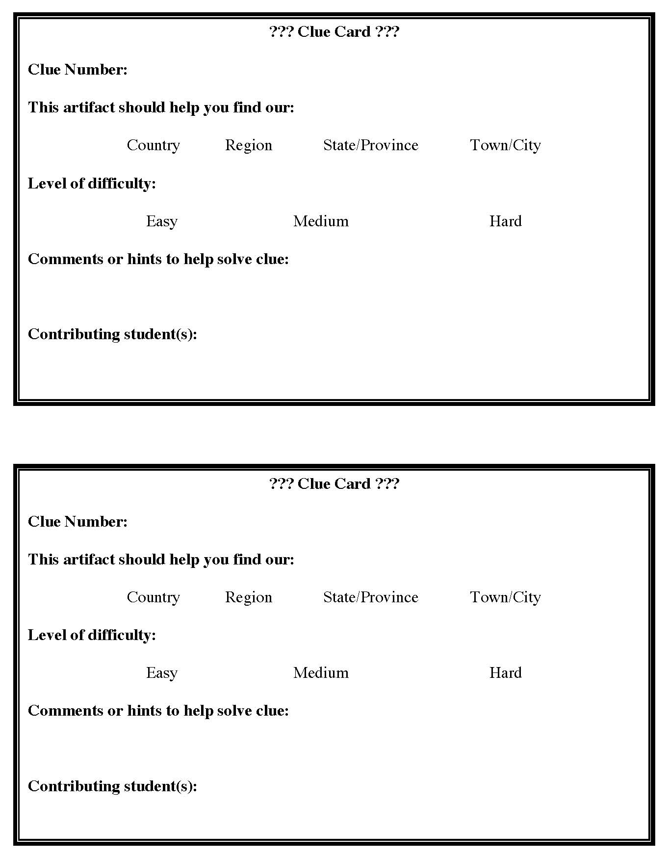
Artifact Box Clue Sheet

Clue # | Submitter’s Name(s) | Possible Reference | Answer to Clue found? | Comments

Sender: Duplicate as many forms as necessary. Complete the left half and mail with your Artifact Box.
Receiver: Complete the right half of this form and return to sender.
Artifact Box Answer Sheet
TOP SECRET!!!
(The Sending School should complete this form and put it in a sealed envelope inside the Artifact box marked TOP SECRET—OPEN AFTER CLUES HAVE BEEN SOLVED.)

Artifact Number | Artifact | Explanation of Artifact:
1 | Weather Forecast
2 | Geography and Land Forms
3 | Non-edible Vegetation
4 | Tree Leaves, Branch, and Bark
5 | Food Product
6 | Manufactured Product
7 | Population
8 | Typical Clothing
9 | Soil Sample

10 | Class Picture
11 | Telephone Book Sample
12 | Portion of State or Province Map
13 | Local Advertisements
14 | Rock or Mineral
15 | Typical Home
16 | Regional/Local Foods and Recipes
17 | State Bird
18 | Animal
19 | Historic Landmark
20 | Famous Person
21 | Newspaper Headline

22 | Letter Envelope
23 | Recreational Activities
24 | Local Author
25 | Original Inhabitants
26 | Other Helpful Clue-A
26 | Other Helpful Clue-B
26 | Other Helpful Clue-C

Artifact Box Evaluation Form
Now that you have researched our Artifact Box, please complete this evaluation form so that we may improve upon it should we do another one. Circle the number that corresponds to the rating for each item. Thank you!

 | Low |  | Medium | High
Difficulty Level of Box* | 1 | 2 | 3 | 4 | 5
Neatness of Clues | 1 | 2 | 3 | 4 | 5
Variety of Resources Needed to Solve our Artifact Box | 1 | 2 | 3 | 4 | 5
Helpfulness of Clues | 1 | 2 | 3 | 4 | 5
Enjoyment of Class Solving our Artifact Box | 1 | 2 | 3 | 4 | 5

What changes should we make if we are to use this box again?
What other comments do you have?
NOTE: The sending school is to send this form along with their completed box to the receiving school. The receiving school is to complete this evaluation form and return it to the sending school along with the solved Artifact Box.

